Financial Accounting
Student Name
Institution Name
Course Number
Due Date
Faculty Name

Section 1: Introduce the company
- What is the company name? What services or products does it provide?
Bayan Investment Co KSCP. It is Kuwait-based company engaged in the provision of investment and portfolio management activities for its own account and for clients and investment in real estate.
- When was the company founded? When was the company listed on the Kuwait Stock Exchange?
Bayan Investment Co KSCP was founded in 1997and it was listed on the Kuwait Stock Exchange in 2018
- What is the company’s industry?
Bayan investment company is a public Kuwaiti shareholding company which is the commerce and industry and Kuwait Capital Markets Authority. It aims at conducting portfolio management operations of its own benefits and the benefit of the third party. In addition to the management of investment funds od several types.
- Who are the competitors for the company?
Bayan Investment company has a number of competitors which include Salhia Real Estate, Kuwait Real Estate, and Commercial Real Estate.
Section 2: Insert Screenshots of the income statement and Financial position for the year ended December 31, 2020

Financial position
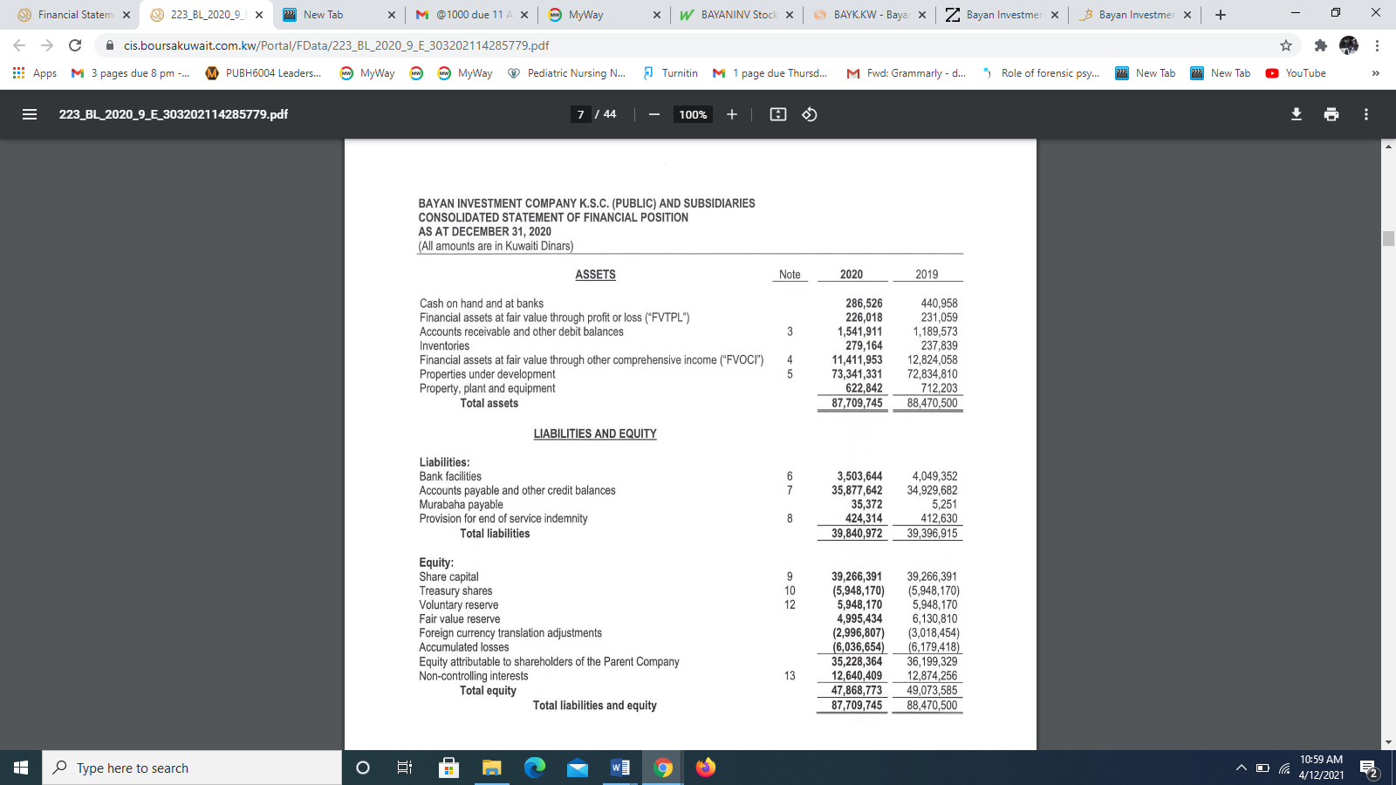
Income statement
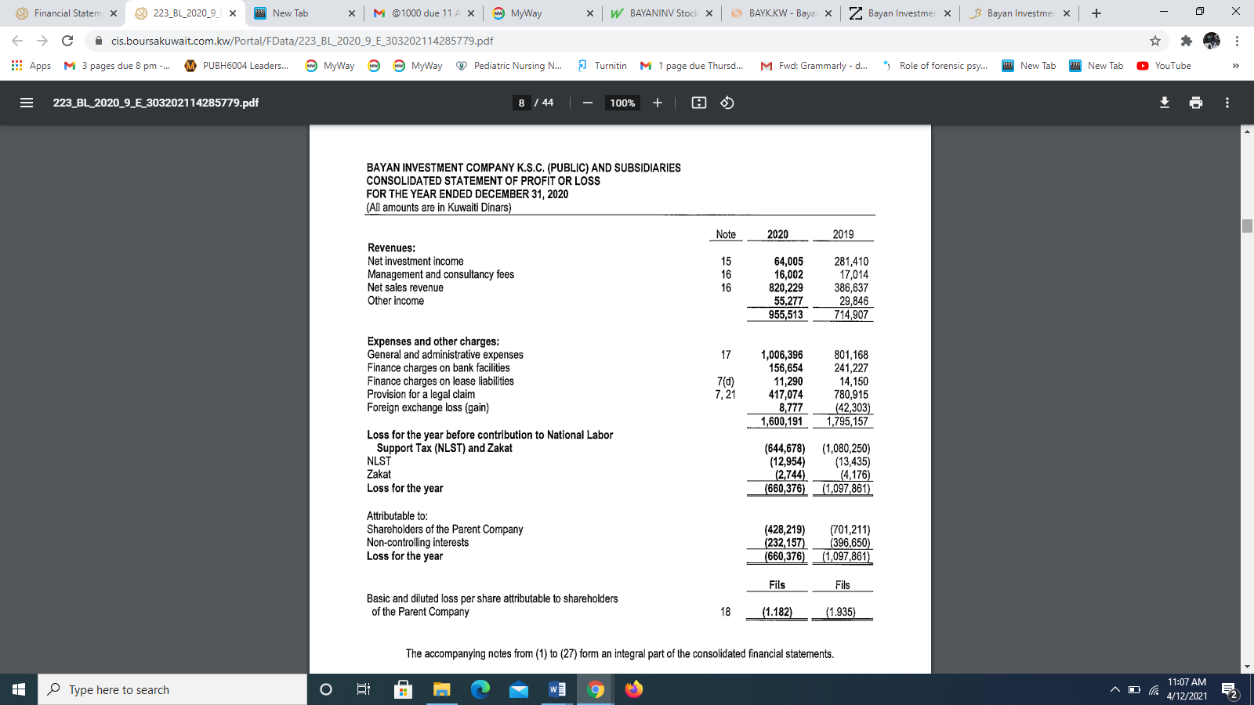

Section 3: Questions about the Income Statement.
- List 2 expense accounts AND their amounts for 2020.
General and administrative expenses – 1,006,396
Finance charges on bank facilities – 156,654
- What was the net profit/(loss) for 2020? What about 2019?
The net loss for 2020 was 660,376
The net loss for 2019 was 1,097,861
- Compared with 2019, has the net profit/(loss) increased or decreased?
There has been a decrease in net loss in 2020. The net loss has reduced by 437, 485
Section 4: Questions about the Statement of Financial Position. 30 marks
- How much was the Cash account balance at December 31, 2020? What about 2019?
The cash account balance at 31, December 2020 was 286, 526 and at 2019 was 440, 958
- Mention the biggest liability with its amount for the company at December 31, 2020.
Accounts payable and other credit balances was the biggest liability for Bayan investment company at 31 December 2020.
c. What was the Total Equity for the company at December 31, 2020? What about December 31, 2019?
The total equity for the company at 31, December 2020 was 47,868,773 and the total equity in 2019 was 49,073,585

